Section A: Basic Hive Operations (5 Questions)
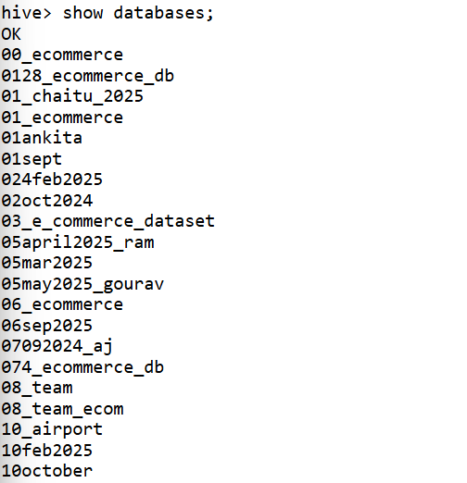
- Show all databases available in Hive.
- Switch to the database named one.
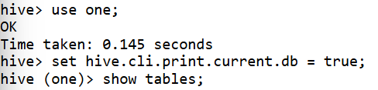
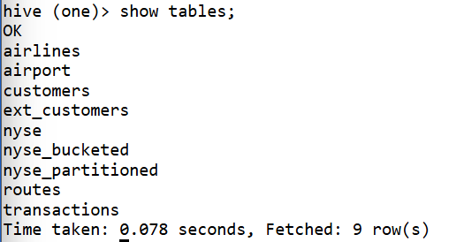
- List all tables present in the current database.
- Display the structure of the airport table.
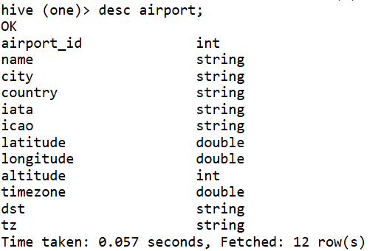
- Display the first 10 records from the airlines table.
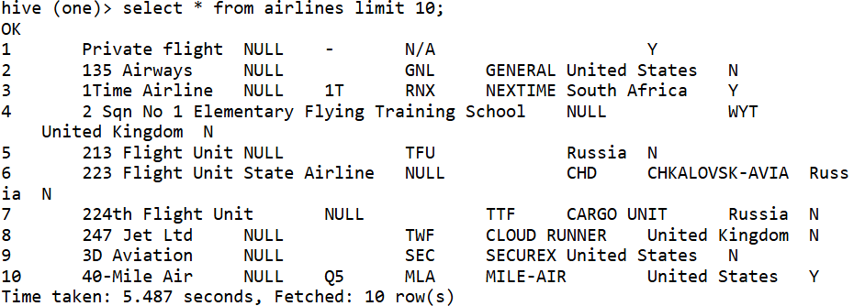

Section B: Filtering and Simple Queries (5 Questions)
- List all airports located in Greenland.
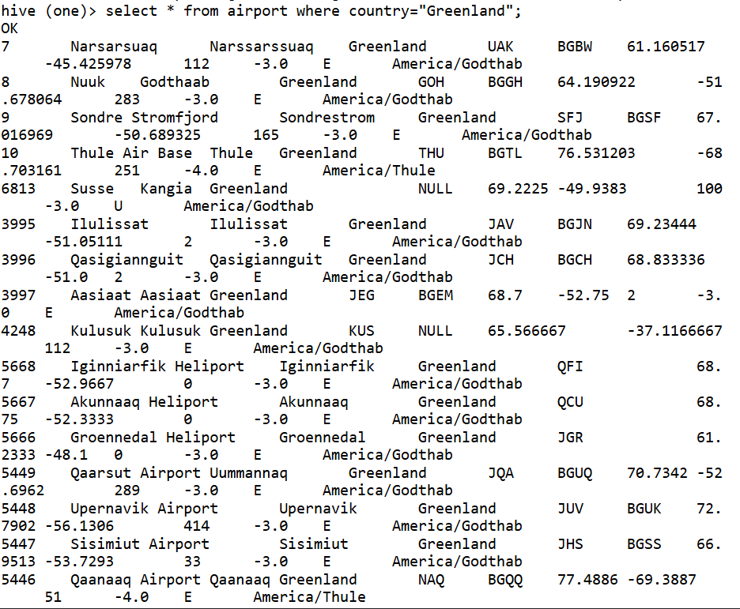

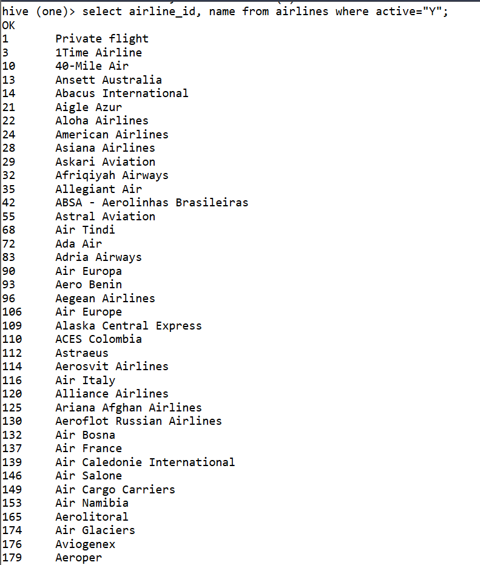
- Find all active airlines.

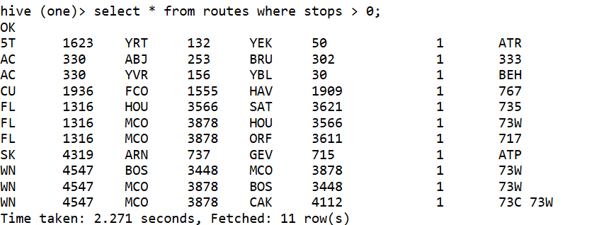
- Display all routes where the number of stops is greater than 0.

- Show details of airports located in Papua New Guinea.
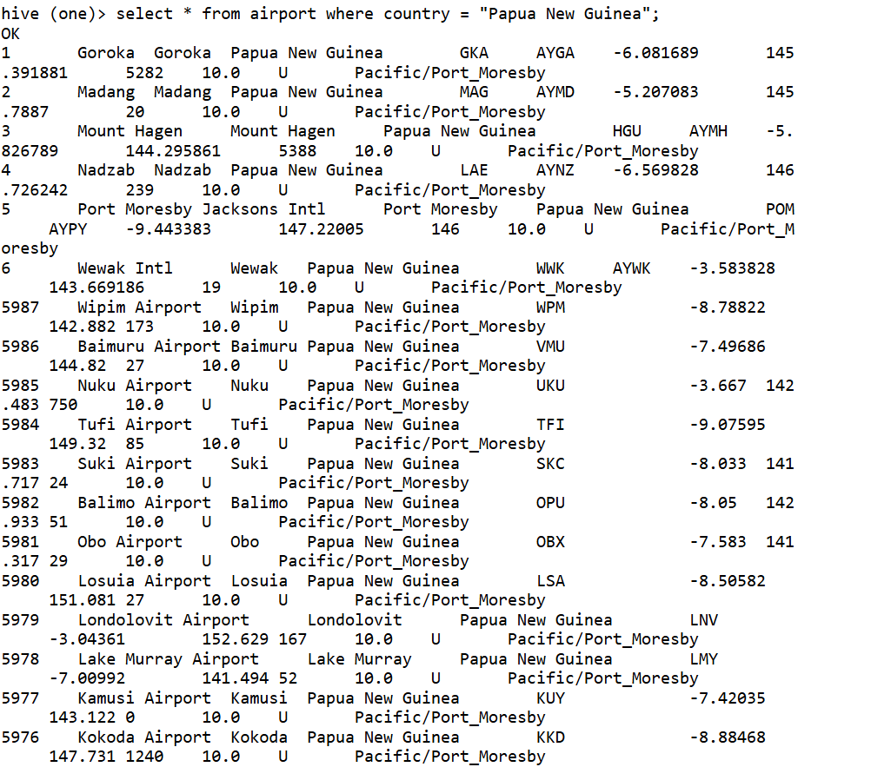

- Display all flights where the destination airport ID is missing (NULL).

Section C: Aggregations (5 Questions)
- Count the total number of records in the airport table.
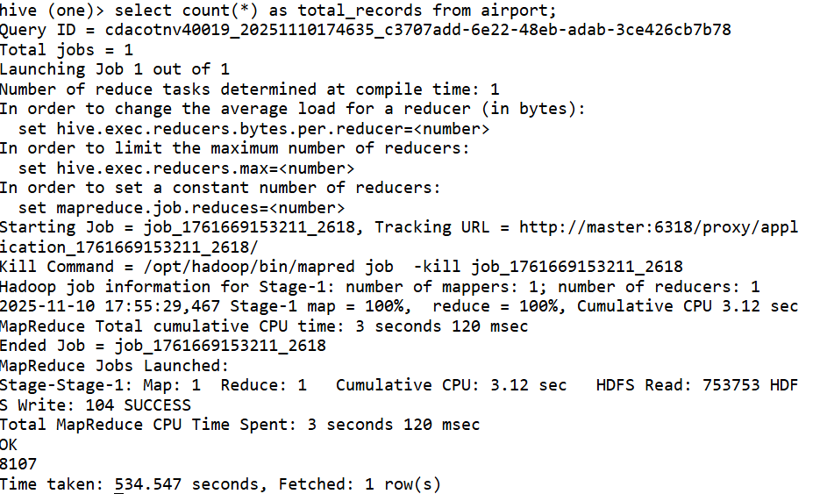

- Find the number of distinct countries in the airport table.
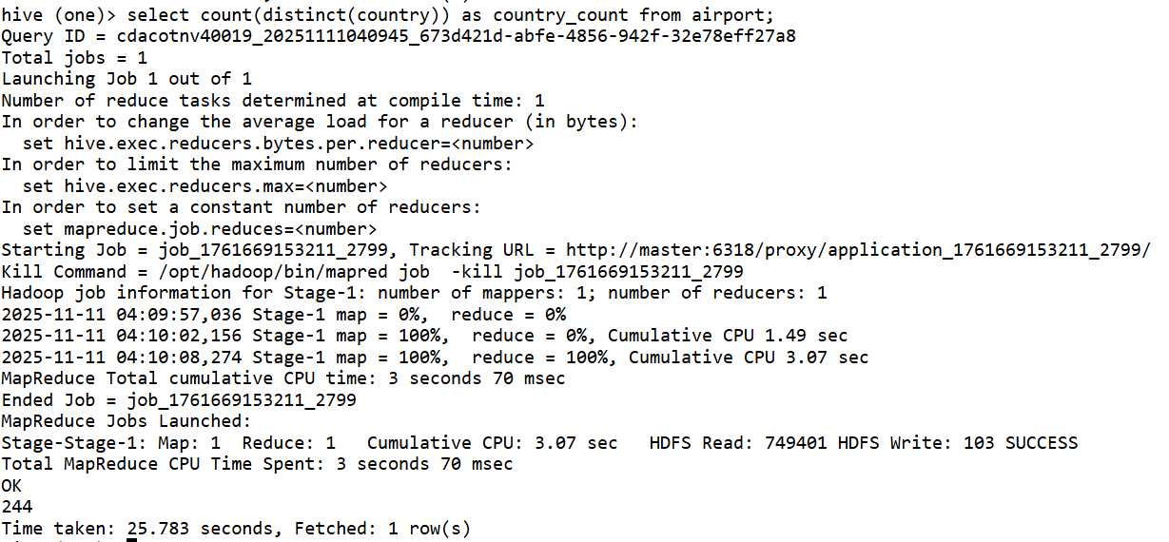
- Find the average altitude of airports by country.
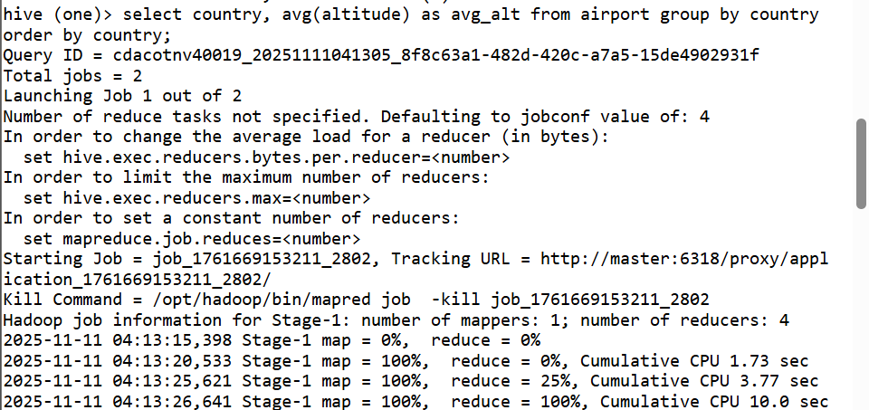
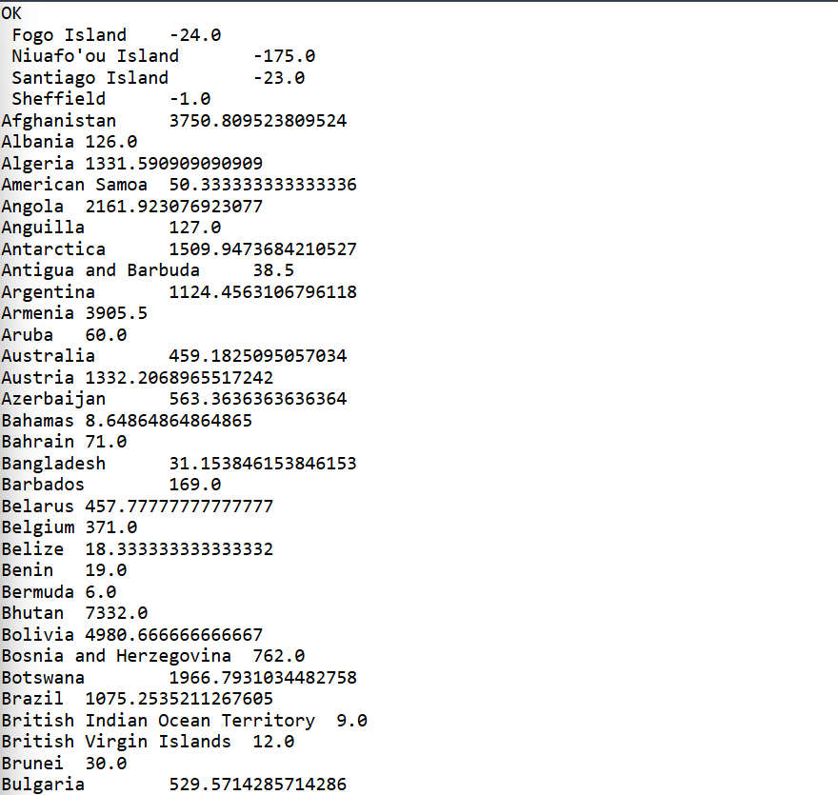

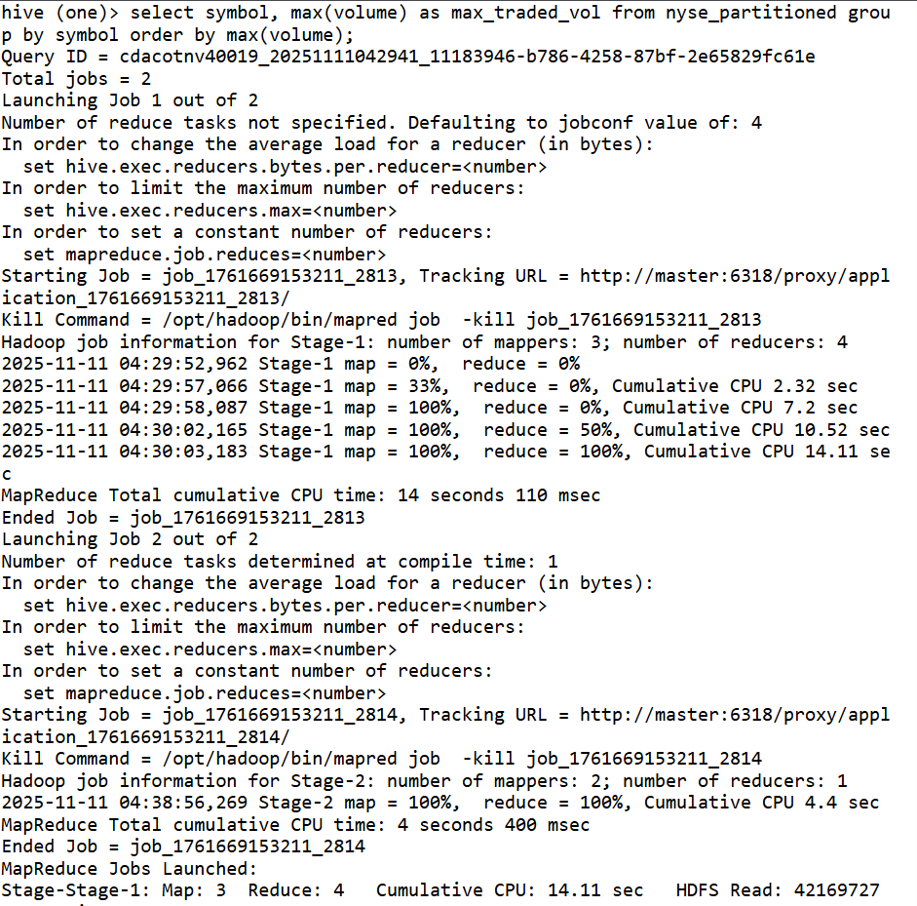
- Find the maximum traded volume for each stock symbol in nyse.

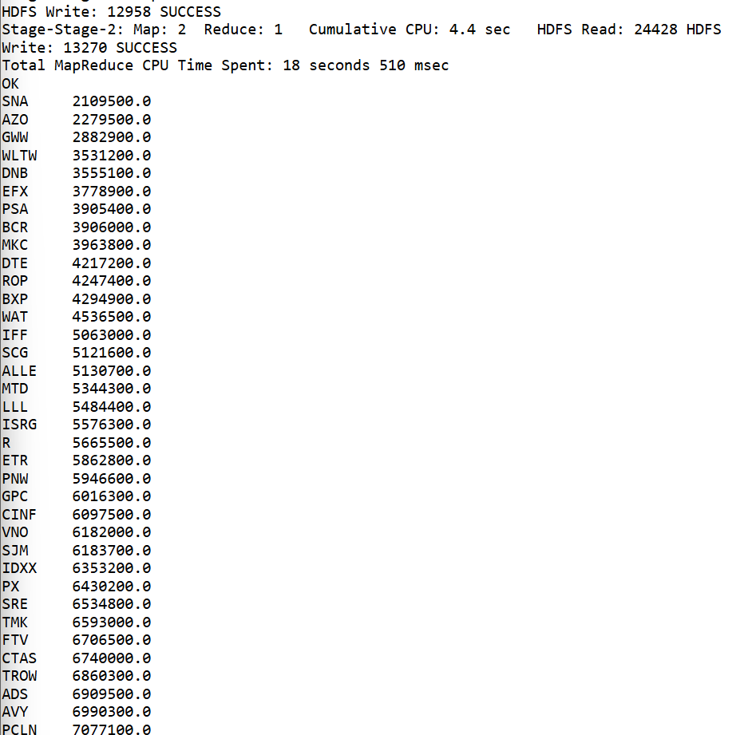

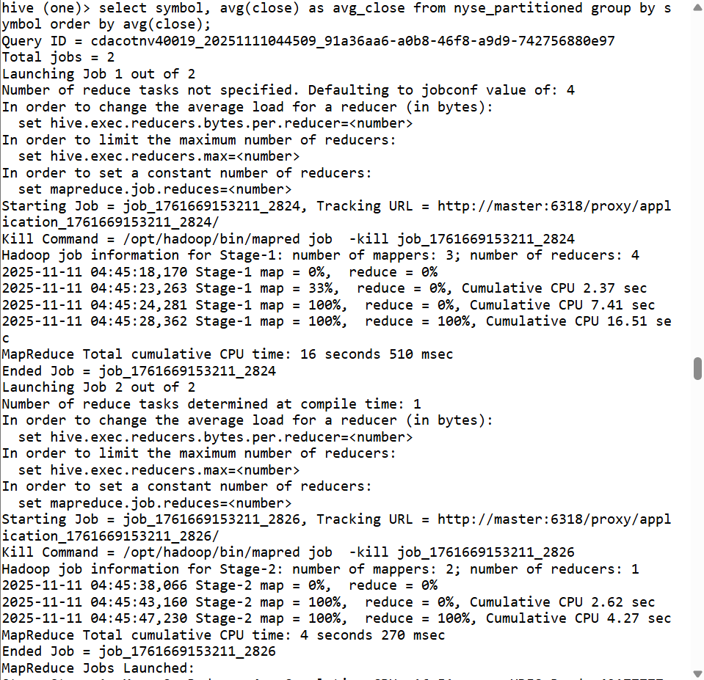
- Find the average closing price per symbol in nyse.

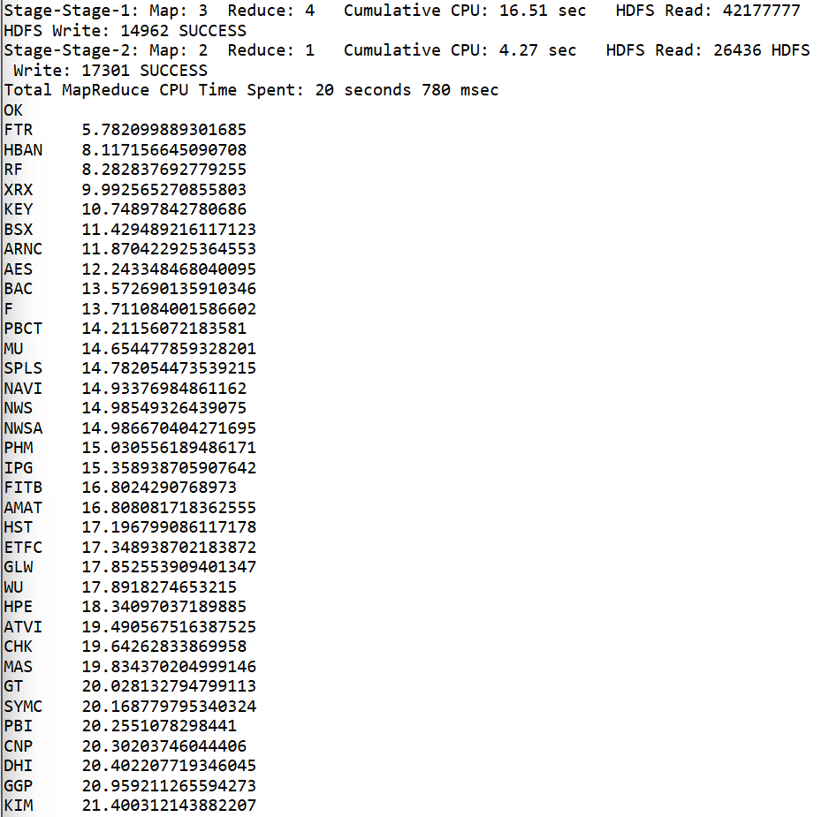

Section D: Group By and Having (5 Questions)
- Find the number of airports in each country.
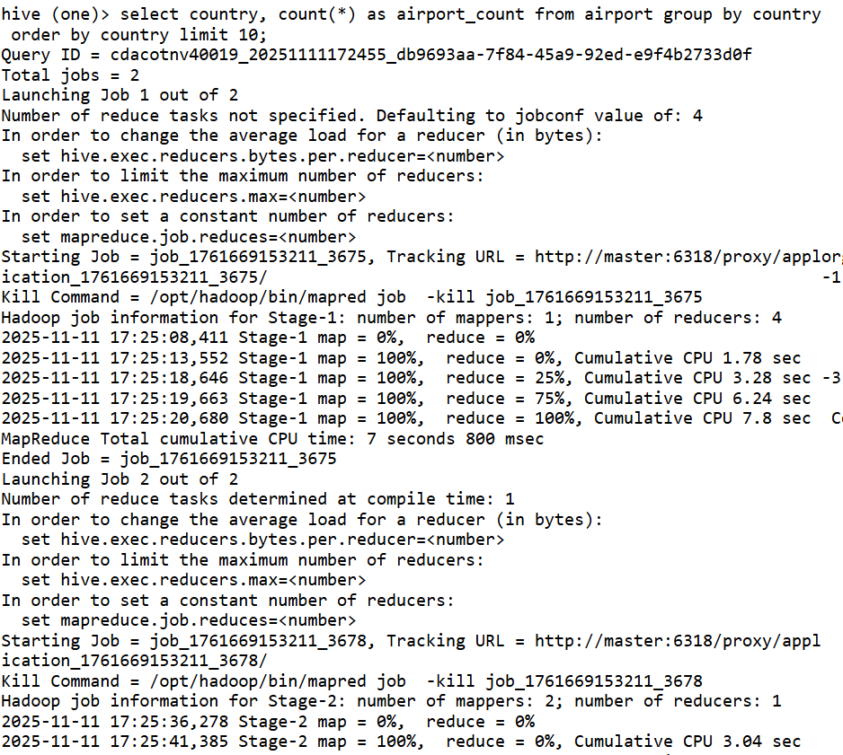
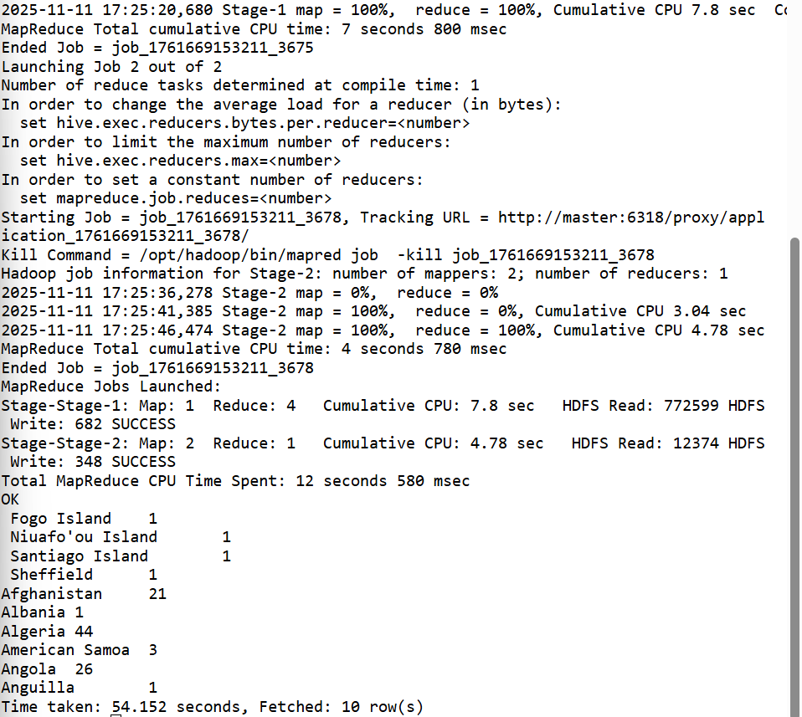

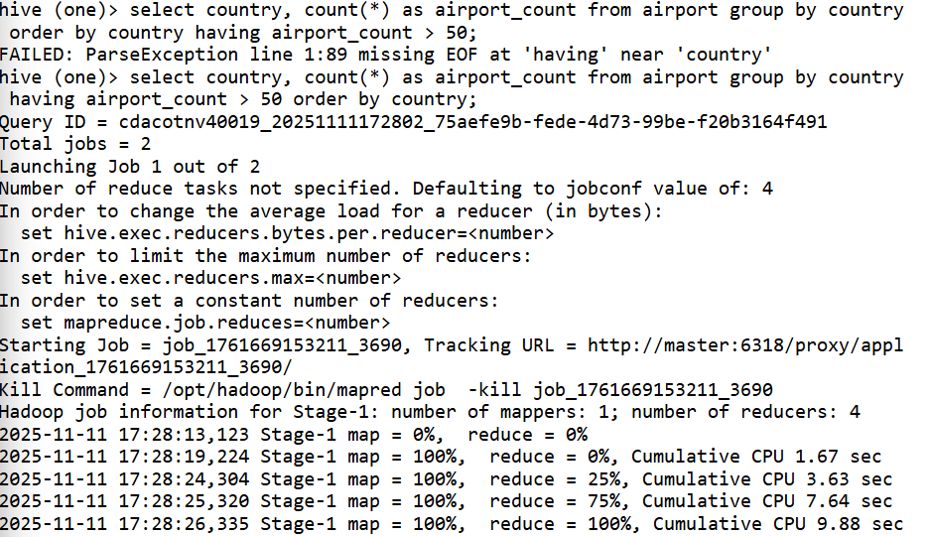
- List countries having more than 50 airports.
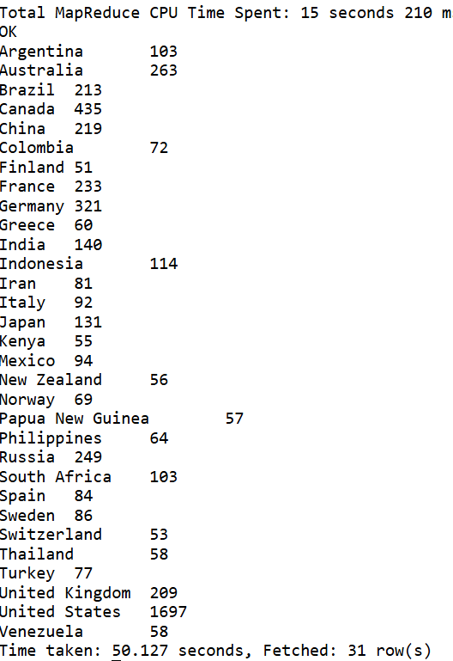

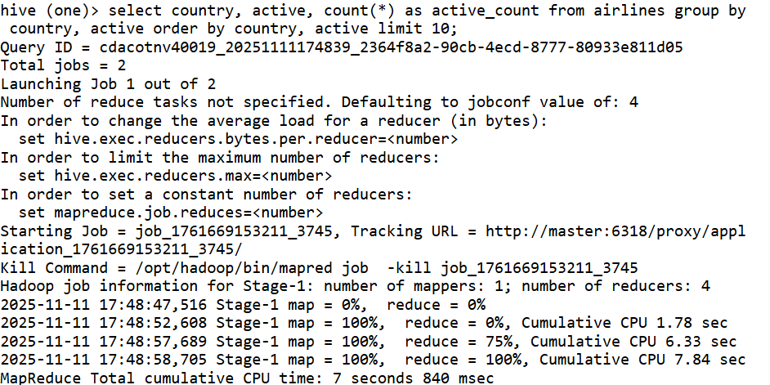
- Find the number of active and inactive airlines per country.

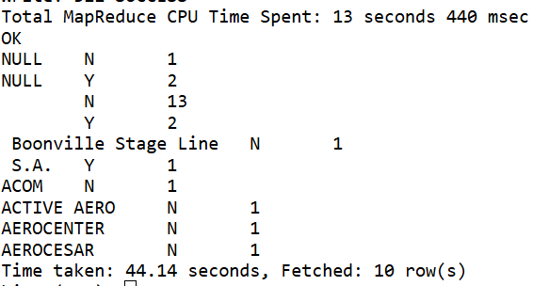

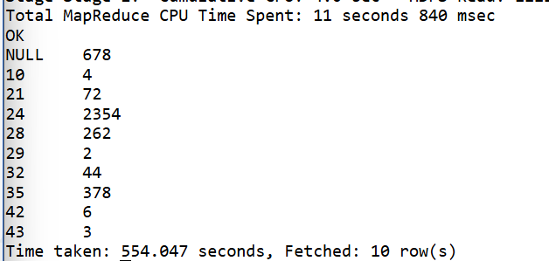
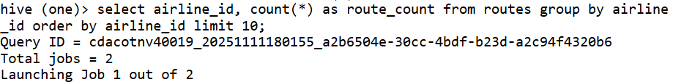
- Show the total number of routes operated by each airline.

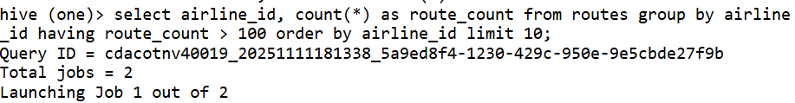
- List airlines that operate more than 100 routes.
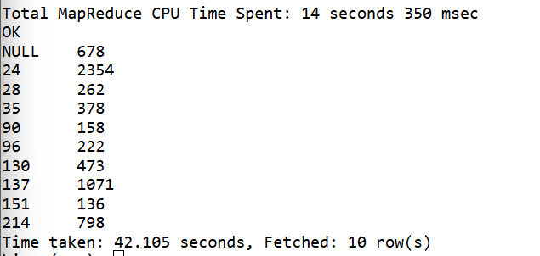

Section E: Joins (8 Questions)
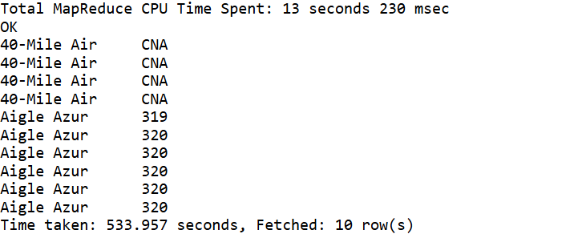
- Join routes and airlines tables to display airline name and equipment used.
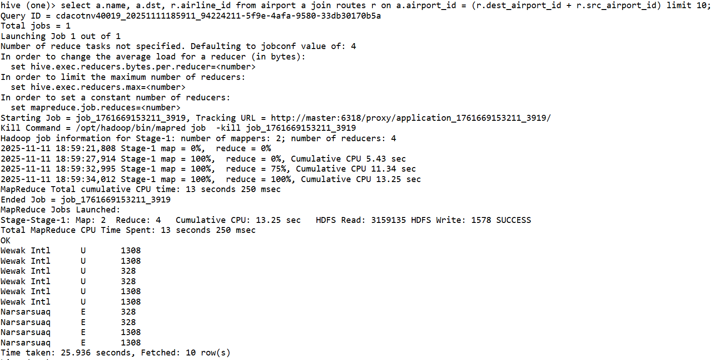
- Find the source and destination airport names for each route.

- Display routes where both source and destination airports are in the same country.
- List all routes operated by Russian airlines.
- Show all unique pairs of source and destination cities for airline 2B.
- Find the total number of routes operated by each airline country.
- Join routes with airport to find the city names of source and destination.
- Find the airline name, source city, and destination city for all flights that stop once.

Section F: Date and String Functions (5 Questions)
- Extract the year from the stk_date column in nyse.
- Count how many records exist for the year 2016 in nyse.
- Find symbols whose name starts with the letter ‘A’.
- Display all airport names in uppercase.
- Find all airlines whose callsign contains the word “AIR”.

Section G: Partitioning and Optimization (3 Questions)
- Create a partitioned table nyse_partitioned based on year.
- Load data into the partitioned table using dynamic partitioning.
- Show all partitions created in the nyse_partitioned table.

Section H: Analytical and Complex Queries (4 Questions)
- Find the top 5 airports with the highest altitude.
- Find the top 5 most frequently used destination airports in routes.
- Rank airlines by the number of routes they operate.
- Find the total traded volume per year for each stock symbol in nyse.
